

**Design Studio #4 - Weekly Progress Report #11**

DS Instructor: Gülbin DURAL

Partners:

* Fatih ÇALIŞ
* Fatih ÇAM
* Recep GÜNAY
* Huzeyfe HİNTOĞLU
* Sarah ILYAS

In this week, we have started building up our chassis for robot. For this purpose, we are planning to use Plexiglass material as shown in Figure 1, which is a transparent thermoplastic often used in sheet form as a lightweight or shatter-resistant alternative to glass.

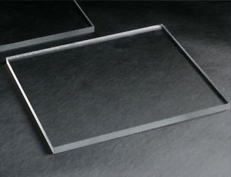

*Figure1: Plexiglass Sheets*

The advantages of using plexiglass is as follows:

1. Shatter-Resistant
2. Flexibility
3. Ease of use
4. Lightness
5. Inexpensive and easily found

Starting with shatter-resistance, our robot should have a high endurance because while moving the robot in the game field, we are going to make agile movements like rotating, shooting etc. Also, considering the weight of the robot, it is important robot to have the property of shatter-resistant. We can say that being flexible material is another reason for aforementioned considerations.

Another important property we care about plexiglass is easiness of use. It can be shaped or bent with hot air gun easily. Moreover, it can be cutted using plexiglass knife or even with a razor. For robot chassis building, it is really important for designing the system according to needs.

Plexiglass material is a light material comparing with wood and some other materials used in robotics. We want our system to as light as possible for known reasons.

Finally, the material is really cheap and can be found easily even from Konya Sokak. There are also some electronics shop markets that have more advanced tools for shaping the plexiglass.

All in all, we are planning to build our chassis using plexiglass due to the reasons mentioned above. We have started mounting the robots on to it. When the base of the robot is completed, we are going to try motor operations. A parallel processing plan is building up our shooting mechanism as reported in the 1st week. We are working on making our shooting mechanism lighter as there may be problems with rotating the wheel designed for shooting. We are planning to solve these problems as soon as possible since CDR deadline is due March 8 which means we have less than 2 weeks. (Huzeyfe Hintoğlu)